MENTORED HOME PRACTICE SUPPORT – RULES OF ROAD REVIEW

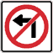
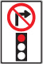


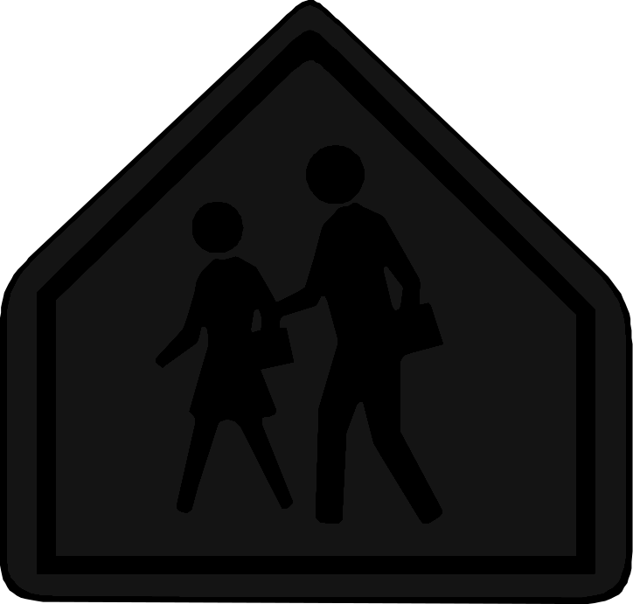

1 2 3 4 5 6 7 8

8) YOU ARE TURNING LEFT AT A 4-WAY STOP. YOU STOP JUST BEFORE AN ON-COMING CAR GOING STRAIGHT, WHO HAS THE RIGHT OF WAY?

9) LIST THE STOPPING POINTS YOU LOOK FOR AT A STOP SIGN: (in order)

10) THE LIGHT IS GREEN BUT A POLICE OFFICER IS HOLDING UP HIS HAND TOWARDYOU, WHAT DO YOU DO?

11) IF YOU WERE IN A SCHOOL ZONE EXACTLY WHEN MUST YOU DO THE SCHOOL SPEED LIMIT?

12) AT A 4-WAY STOP IF TWO CARS STOP AT THE SAME TIME, WILL THE CAR ON THE LEFT OR RIGHT HAVE THE RIGHT OF WAY?

13) YOU WANT TO TURN LEFT AT A 4-WAY UNCONTROLLED INTERSECTION. WILL YOU HAVE TO YIELD TO ON-COMING CARS?

14) CAN YOU PARK ON THE STREET WITH YOUR CAR PARKED AGAINST THE"FLOW OF THE TRAFFIC?"

15) LINES SEPARATE TRAFFIC MOVING IN THE SAME DIRECTION.

16) WHY MUST VEHICLES BE PARKED ABOUT A KILOMETER FROM A STOP SIGN?

17) WHAT DO ORANGE COLOR SIGNS MEAN?

18) TRUE OR FALSE: YOU SHOULD BE AT LEAST .5 KILOMETERS AWAY FROM A FIRE PLUG WHEN YOU PARK.

19) WHEN YOU PARK DOWNHILL WITH A CURB, WHICH WAY WILL YOU TURN YOUR WHEELS?

20) WHAT DOES THE LAW REQUIRE IF AN EMERGENCY VEHICLE
APPROACHES?

21) IF YOU ARE ON THE LEFT SIDE OF THE STREET MAKING A LEFT TURN, WHAT TYPE OF STREET ARE YOU ON?

22) HOW FAR IN ADVANCE OF A TURN SHOULD YOU SIGNAL IN A CITY OR RESIDENTIAL AREA?

23) WHAT SIDE OF THE STREET SHOULD PEDESTRAIN BE WALKING ON?

24) WHAT IS THE "BASIC SPEED LAW?"

25) HOW MANY KILOMETERS IN ADVANCE OF A TURN SHOULD YOU SIGNAL IN ARURAL AREA? (SPEEDS ABOVE 60 KM/PH

42) WHAT DOES A FLASHING GREEN LIGHT MEAN?

43) YELLOW DASHES ON THE PAVEMENT SEPARATE TRAFFIC MOVING IN WHAT DIRECTION?

44) EXPLAIN THREE PARKING VIOLATION?

45) IS IT LEGAL TO PARK IN FRONT OF YOUR OWN DRIVEWAY AT HOME?

46) CAN YOU PASS A SCHOOL BUS WITH IT'S YELLOW LIGHTS FLASHING?
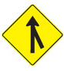
47) IS THIS A MERGE SIGN?

48) HOW FAR AWAY FROM A CURB CAN YOU PARK BEFORE BEING IN VIOLATION?

49) WHAT DOES A SIGN WITH A LETTER "H" ON IT MEAN?

50) WHEN IS A RIGHT TURN ON RED NOT ALLOWED AT A TRAFFIC LIGHT?

51) IF THERE IS A SCHOOL BUS FLASHING RED LIGHTS ON THE OTHER SIDE OF A 4-LANE ROAD, YOU MUST STOP...TRUE OR FALSE?

52) IF THE TRAFFIC LIGHTS ARE OUT OF ORDER WHAT MUST YOU DO?

53) PARKING UP-HILL WITH A CURB ON THE RIGHT SIDE OF THE STREET YOUR WHEELS WILL GO TO THE____________

54) A PEDESTRAIN IS CROSSING IN THE MIDDLE OF THE BLOCK. DOES HE HAVE THE RIGHT OF WAY?

55) TRUE or FALSE: IT IS LEGAL TO PULL UP ALONG SIDE A MOTORCYCLE IN ITS LANE AS LONG AS YOU GIVE IT PLENTY OF ROOM.

56) WHEN MAKING A RIGHT TURN ON RED, WHAT 2 THINGS DOES THE LAW REQUIRE?

57) A YELLOW SPEED LIMIT SIGN IS WHAT TYPE OF SIGN?

58) A GREEN AND WHITE ROUTE SIGN IS WHAT TYPE OF ROUTE SIGN?

59) WHAT DOES A PEDESTRAIN WITH A WHITE CANE TELL YOU?

60) WHAT SHOULD YOU DO WHEN YOU APPROACH A TRAFFIC SIGNAL LIGHT WHICH SHOW BOTH A RED LIGHT ANDA GREEN ARROW IN THE DIRECTION
YOU WANT TO GO?

61) IS IT EVER LAWFUL FOR A DRIVER TO USE A GAS STATION OR OTHER CORNER BUSINESS PARKING LOT TO AVOID A TRAFFIC LIGHT?

62) MAXIMUM SPEED LIMIT IN SCHOOL ZONES?

63) MAXIMUM SPEED LIMIT IN ALLEYS?

64) MAXIMUM SPEED LIMITS IN RURAL AREAS?

65) WHAT IS THE MAXIMIM SPEED LIMITS IN CITY AND TOWN AREAS? (unless posted otherwise)

66) HOW LONG WILL YOUR FIRST G-1 DRIVERS LICENCE BE VAILD FOR?

75) CAN A DRIVER LEGALLY MAKE A LEFT TURN ON A RED LIGHT?

76) WHAT SHOULD YOU DO IF YOU ARE WITHIN AN INTERSECTION WAITING TO MAKE A LEFT TURN AND THE TRAFFIC SIGNAL LIGHT TURNS RED?

77) IS IT PERMISSIBLE FOR YOU TO PASS ON THE SHOULDER OF THE ROAD?

78) WHAT IS THE MAXIMUM SPEED LIMIT ON FREEWAY ROADS AWAY FROM CITIES?

79) WHAT MUST A DRIVER DO WHEN MOVING OUT OF AN ALLEY, PRIVATE ROAD, OR DRIVEWAY IN AN URBAN AREA?

80) WHEN MAY YOU PROCEEED IF YOU ARE WAITING AT AN INTERSECTION AND THE LIGHT FINALLY TURNS GREEN?

81) WHAT ARE YOU REQUIRED TO DO WHEN APPROACHING A MARKED CROSSWALK WHERE PEDESTRAINS ARE CROSSING THE ROAD?

82) ARE DRIVERS ALLOWED TO WEAR MUSIC ELECTRONIC DEVIVES WHILE DRIVING?

83) WHAT LANE SHOULD SLOWER VEHICLES USE EXCEPT WHEN PASSING OR TURNING LEFT?

84) WHAT CAN HAPPEN IF YOU PARKING IN A HANDICAPPED SPOT?

85) WHAT DOES A RED X ABOVE A TRAFFIC LANE MEAN?

86) WHAT ARE THE THREE D's OF GREEN SIGNS COMMONLY FOUND ON FREEWAYS?

87) WHAT SIDE OF THE STREET SHOULD PEDESTRIANS BE WALKING ON?

88) BROWN COLOR SIGNS ARE USED FOR WHAT?

89) WHAT DOES A FLASHING YELLOW LIGHT MEAN?

90) TRUE or FALSE: EVERYONE MUST WEAR A SEAT BELT.

91) WHAT ARE BLUE COLOR SIGNS USED FOR?

92) EXPLAIN HOW THE 3-SECOND FOLLOWING RULE WORKS.

93) WHAT DO FLASHING RED LIGHTS MEAN?

94) WHAT DOES A DRIVER'S ARM SIGNAL MEAN THAT IS STRAIGHT OUT THE WINDOW

95) CAN YOU PASS A VEHICLE WITH A SOLID YELLOW LINE ON YOUR SIDE?

96) WHAT DOES A DRIVERS ARM SIGNAL MEAN THAT IS POINTING UPWARDS OUT THE WINDOW?

97) EXPLAIN WHEN IT IS ILLEGAL TO HITCHHIKE?

98) WHAT DOES A DRIVERS ARM SIGNAL MEAN WHEN IT IS OUT THE WINDOW POINTING DOWN?

99) WHAT A DOUBLE YELLOW LINE ON A TWO-LANE ROAD INDICATE?

100) WHAT IS THE MAXIMUM NUMBER OF PEOPLE ALLOWED TO RIDE IN THE FRONT SEAT OF A VEHICLE?

